Formal Curriculum
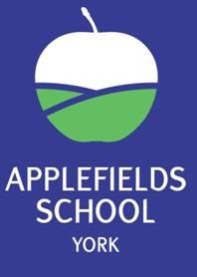

Wellbeing and Regulation,
Communication and Independence, Personalisation and Preparation

Contents

- Our Curriculum Journey

- Applefields Formal Curriculum
  - Formal Curriculum aim
  - Curriculum overview
  - Provision on a page

  - Personal Development and Preparing for Adulthood

  - British Values

  - My World

  - RHSE

  - Wellbeing

  - Discovery Days

  - Visits

  - Work Related Learning

  - Pathways

  - Preparation for Adulthood

  - Destinations

  - Accreditations

  - Planning expectations

  - Marking and feedback

Recording and Reporting

  - EHCP Outcomes and Tracking

  - Recording and Reporting on the Formal Curriculum

  - Small steps

  - Evidence for Learning

  - Other assessment tools through EfL

  - Work Books/ Folders

  - Pupil Files

- Additional Provision and Intervention on the Formal Curriculum

i. RM, Wordshark, Clicker 8 & Education City

ii. Additional Specialist Support

- Key information about pupils on the Formal Curriculum

  - Definition of Moderate Learning Difficulties (MLD)

  - Needs of pupils with MLD

  - Pupils with MLD at Applefields School

References and Acknowledgements
- Our Curriculum Journey

Applefields began changing the school curriculum during the academic year 2017 -2018. Following extensive visits by senior and executive leadership to many settings, research of settings and studying key SEND documentation; Rochford Report, EQUALS and MAPP (acknowledged in references), we were able to decide as a leadership team how we wanted our curriculum to look. We wanted to have a curriculum which was meaningful and led each young person into adult life and in doing so matched the aspirations and outcomes that had been planned through their Education, Health and Care Plans.

Initial research was conducted in order to ascertain views of staff, parents/ carers and students. Governors have also been fully consulted. This overwhelmingly highlighted the need for a life skills based curriculum, communication throughout everything and wellbeing and regulation being central.

During 2020 and the Covid-19 pandemic, we were able to assess where we were at. We injected significant funding into IT, home learning and resourcing. We made the brave decision to pause on assessment systems and purchased Evidence for learning. We decided to use MAPP across school rather than with our more complex learners. From 2020 to 2022 we have been building meaningful curriculum documentation to support our curriculum pedagogy for formal learners and now we are reviewing and refining its implementation and impact.

Our formal curriculum is largely based on the Primary National Curriculum with adjustments made to ensure our students have the time to overlearn and deepen what is relevant for their communication, independence and preparation for adulthood objectives. We believe strongly that students need to be well regulated to learn and have their wellbeing needs met, the pandemic has highlighted this further and from what we have seen and achieved through our recovery curriculum.

Our Formal Curriculum is a solid foundation for learning core skills in key subjects such as English- communication and Maths- thinking skills. We have a menu of lessons and objectives built around our termly themes but learning may look different for each student due to their individual needs and personalised timetable, which are devised to meet their identified needs and EHCP outcomes.

- Applefields Formal Curriculum

‘Pupils with MLD will have attainments well below expected levels in all or most areas of the curriculum, despite appropriate interventions. Their needs will not be met by normal differentiation and the flexibilities of the National Curriculum. Pupils with MLD have much greater difficulty than their peers in acquiring basic literacy and numeracy skills and in understanding concepts. They may also have associated speech and language delay, low self-esteem, low levels of concentration and under developed social skills.’
Department of Education and Skills (2003)
The school environment/curriculum can present a range of barriers to participation and learning for pupils with MLD. The SEN Code of Practice says that pupils who demonstrate features of MLD or specific learning difficulties require specific programmes to aid progress in cognition and learning. Pupils with MLD may need support with:

- understanding instructions and the requirements of tasks
- acquiring sequencing skills − for example, when following a recipe or science experiment
- understanding how they affect and relate to their immediate surroundings personal organisation over the short, medium and long term, and
- visual and auditory memory for information, processes and instructions.

Careful assessment of baselines and monitoring of progress will help ensure that their progress can be recognised and built upon.

For pupils with Moderate Learning Difficulties. Some, perhaps many, of this population may also have a diagnosis of an autistic spectrum condition (ASC). Our Formal curriculum is for pupils engaged in subject specific learning who are consistently and over time working at levels below/ well below age related expectations.
Our formal learners span across 3 sites and make up approximately one third of our school population.

Formal Curriculum Aim:

Our curriculum at Applefields is skill and context based and encourages active engagement in learning. The curriculum focuses on developing the key skills of communication, cognition, independence, physical development, self-care and regulation, all transferrable skills that equip young people for life beyond the school.

Our curriculum strives to be responsive to each learner, and build on individual strengths and interests. A thematic plan is in place, which supports a balance of stimulating contexts for learning through different learning experiences and subjects.

Curriculum Overview:

KS3 | (KS4) 14+ Moving on Curriculum | Moving on Zone (MOZ)
English  Maths  Communication  IT Skills  Life Skills  My World  Creativity  PE  Leisure  Work Related Learning  Wellbeing | Functional English  Functional Maths  Communication  IT Skills  Life Skills  My World  Creativity  PE  Leisure  Work Related Learning  Wellbeing | Life Skills  Transition  Pathways; Catering, Online Retail, DT  Leisure, PE and Wellbeing  Communication, Functional English & Maths and IT Skills are taught through the above

National Curriculum subjects are taught through a thematic approach, with a strong emphasis on life skills, communication and wellbeing. Teachers adapt termly themes under the overarching headers of Global, Ecology and Community to meet the specific needs of their pupils so they are challenged and delivered in an age-respectful way.

Pupils who attend Satellite Provision will attend one or more mainstream inclusion lessons as part of their week and, from Year 9 it is anticipated, may follow an accredited course. This is considered carefully to create a balance on other lessons and qualifications. The Satellite criteria has further information about the bespoke offer.

Provision on a page KS3/4

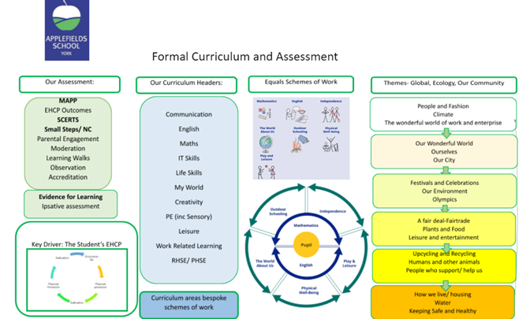

Personal Development and Preparing for adulthood

Wellbeing and Preparing for Adulthood is the golden thread running through our Formal Curriculum. Our life skills curriculum focuses on five core areas of learning. They are:

- Cookery
- Travel
- Community
- Home
- Self

These core skill areas are also developed through cross-curricular links, enrichment activities and extra-curricular opportunities such as bikeability and travel training.

British Values:

In 2014, the DfE reinforced the need “to create and enforce a clear and rigorous expectation on all schools to promote fundamental British values”. The Government set out its definition of British values in the 2011 Prevent Strategy. Listed below are the values with examples of how Applefields uphold them;
- Democracy; School council, fair trade committee, class rights and rules, voting, debates
- The rule of law; PCSO/ Police/ fire service visits, online safety, IPIP agreements, code of conduct
- Individual liberty; choices, independence- tuck shop/ café/ work experience/ pathways/ golden time, travel training, sports club, ASDAN- towards independence
- Mutual respect; ELSA, circle time, check ins, wellbeing work, breakfast club, wellbeing room, chill out rooms, achievement assemblies, coffee mornings
- Tolerance of those of different faiths and beliefs; RE lessons, YOYO Assemblies, festivals, events, themes

These five areas are taught across the curriculum and threaded through the work of the school. The sense of community is very strong across our school sites – staff, pupils, Governors and families are all part of our community.

What is My World?

In addition to subject specific English, maths and Functional English and maths Open Award accreditations, pupils follow a thematic based curriculum. My World incorporates the following subjects; Science, History, Geography and RE. By teaching in this way, it allows learning to be less fragmented and provides an ‘umbrella’ that links the development of knowledge and skills across a broad range of subject areas linked to a theme. This style of learning also enables pupils to revisit the same or similar ideas and apply them in different ways, resulting in a deeper understanding of the topic. This is known as the spiral model. When planning for 'My World’, staff take into account personalisation for their class and may adapt the menu of options accordingly. Applefields school values; Wellbeing and Regulation, Communication and Independence, Personalisation and Preparation are at the heart of everything we do.

RHSE

Relationships and Sex Education (RSE) in secondary schools was compulsory in England from September 2020. The statutory Government guidance ‘Relationships education, relationships and sex education (RSE) and health education’ (2019) frames considerations for disabled pupils and pupils with special educational needs (SEN) within the Equality Act 2010 and the Children and Families Act 2014. Our PSHE association and EQUALS subscription helps us to keep up to date with planning and guidance. Pupils are taught in same sex groups and RHSE is very bespoke to each student’s individual needs.

Wellbeing

Wellbeing and regulation are key to how our students learn, thrive and progress. We use the zones of regulation in classes and each class has individual reward systems in which they celebrate small steps. Our wellbeing team are on hand should students need a referral and specific work. We have Emotional Literacy Support Assistants (ELSAs) in school who will also work with students for short term projects.

Discovery Days

At Applefields we celebrate key events and religious festivals. This is one of the occasions in which the students come together with the other curriculums to celebrate and learn as a whole school.
Visits

Visits include both enriching experiences and preparing for adulthood opportunities. We value repeated visits so that our pupils have the best possible chance at accessing their community in the future. This includes accessing public places such as going to the café or going to the shop. Pupils learn the sequence of the visit, how to pay for items and develop important communication skills.

Work Related Learning at Applefields

Our work related learning programme through Key Stages builds upon learning about work, visiting places and learning about jobs in our community. WRL provides pupils with opportunities to experience work pathways, develop personal qualities and gain work-related skills to help enable pupils to make an informed choice about their future.

What are Pathways?

Our MOZ and 14+ mainsite curriculum provides pupils with opportunities to experience work pathways, develop personal qualities and gain work-related skills to enable students to make an informed choice about their future. The current pathways we teach are;

- Cater 4 it
- Make it
- Sell it

Preparation for Adulthood:

The Formal Curriculum focuses on developing core functional skills that will best prepare pupils for adult life. Pupils on the Formal Curriculum are supported to achieve accreditation if appropriate. There are no entry requirements for the further education college courses listed. Pupils may opt to leave Applefields School at any point from the end of Year 11.

Possible destinations (not an exhaustive list):

Formal
Employment  Supported Employment  Vocational Learning  Volunteering  Further Education  Performing/ Creative arts | Choose 2  Blueberry Academy  Askham Bryan  Ampleforth Plus  York College- Pathways  Tang Hall Smart- Smartways

Accreditations:

Pupils have the opportunity to work towards the following nationally recognised accreditations;
- ASDAN
- Open Awards provide our students with functional maths and English knowledge, skills and understanding that enables them to operate confidently, effectively and with independence in life and work.
Planning

An example of our yearly thematic formal long term planning.

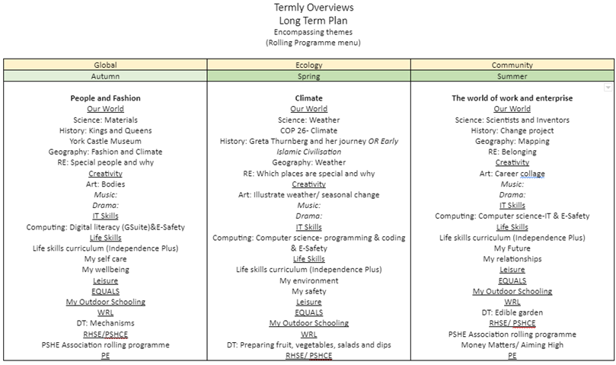

An example of objectives linked to themes
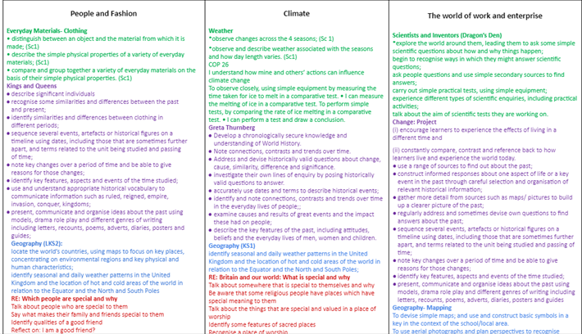
Planning should be personalised to each class.

When planning it should include the following information:
- Learning intentions (INTENT)
- Success criteria (Key steps a pupil needs in order to fulfill the learning intention) (IMPACT)
- Differentiated activities and resources (IMPLEMENTATION)
Great short term planning will include;
  - Shared LI and success criteria written in child friendly language. (These could be shared through a Google Slides presentation, task booklets or worksheets)
  - Shared LI focus on the learning journey, not just the completion of the task or activity.
  - Information on deployment of staff eg 1-1, small groups

Marking and Feedback

Teachers are required to provide verbal and written feedback in-line with the school Feedback and Annotation Policy. Evidence for Learning (EfL) may also be used for feedback and student self reflection.
These written comments should:
- Be directed to the student, be positive and celebrate effort and achievement
- Relate to learning objectives

Teachers should indicate next steps for improvements or correcting errors on a pupil's work. Opportunities are given for these points to be shared, reflected upon and action taken. Where a pupil has received verbal feedback, VF will be annotated on the pupil's work.
Teachers and teaching assistants are required to provide verbal and written feedback to pupils.

Code |  | Levels of support/ annotation codes explained
I | Independent: The task was completed independently
SH | Spoken help: Including signing and verbal prompts to remain on task
GH | Gestural help: Help from someone who has used gestural cues
PH | Physical help: help by someone holding / helping a student move
C | Corrected: Work corrected/ requires correction
 | Next steps: Target/ challenge or next steps information recorded for student
S | Scribe: Work/ notes recorded by someone else
VF | Verbal Feedback: Verbal feedback has been provided following the task

Leuven Scale:

2. Formal Curriculum Recording and Reporting

EHCP outcomes and tracking:

Outcomes are written by the class teacher, class team, parents, students and wider professionals and are agreed at EHCP meetings and parental consultations.
Parents are invited for consultation each term to discuss progress and revise outcomes.
Students are aware of their outcomes and these are mapped in class so the student is at the heart of the process.

In addition to this, outcomes from each pupils’ Education, Health and Care Plan are monitored and tracked during termly pupil progress meetings with a member of Senior Leadership. Information is used to create case studies, provide interventions and create impact reports. This robust way of monitoring is summarised and presented for the scrutiny of school Governors.

Steps to pupils achieving outcomes are recorded in our assessment tools, MAPP and Evidence for Learning and other observational records in class in conjunction with the student.

A blank example of Applefields EHCP monitoring table below:

This section completed by:
Short term Outcome | Date outcome set | Progress made
N1 Communication and Interaction
N2 Cognition and Learning
N3 Social, Emotional and Mental Health
N4 Physical and Sensory Needs (Vision / Hearing)
N5 Sensory Needs
N6 Preparation for adult life

All pupils have personalised long and short-term outcomes (STO) in their Education, Health and Care Plans. Teachers make a judgement on the pupil’s progress towards their STO during pupil progress meetings. Once a pupil has achieved their outcome, this is recorded and a new outcome is set on their EHCP in conjunction with parents, the student and professionals.

Recording and reporting on the Formal Curriculum

We use the MAPP assessment tool; independence, fluency, maintenance and generalisation (Sissons, 2010 )to track progress in areas where students have identified needs. Areas are;

- Communication and interaction
- Cognition and Learning
- SEMH and Wellbeing
- PFA
- Sensory (if identified needs in this area)
- Physical and medical (if identified needs in this area)

The system tracks good, expected, and stagnated progress and is monitored through termly pupil progress meetings. Our Evidence for Learning tracking system measures and monitors progress in each area to enable us to provide support and interventions where necessary. We do not believe our student’s progress is comparable with each other due to their individual special educational needs and disabilities.

from dependent INDEPENDENCE to independent
Learners complete tasks independently
The task is carefully scaffolded and the learner is fully prompted throughout. | Some elements of the task are completed without support (or the overall level of support is lighter, for example physical help is replaced by gestural help). | The learner performs the task with minimal support. Encouragement may be given, and prompting may be needed to initiate the relevant skill(s). | The learner initiates the appropriate action and completes the task independently without prompts or other external cues.
1 2 | 3 4 5 | 6 7 8 | 9 10

from approximate FLUENCY to accurate
Learners reach a level of mastery combining speed and accuracy
The skill is approximate and the learner’s behaviour needs considerable shaping in order to accomplish the task. Performance is slow and halting. | The learner’s performance is increasingly purposeful and coordinated, but it is not yet sufficiently accurate to effectively accomplish the task. | Performance is sufficiently accurate to meet the requirements of the task which is completed with little faltering or hesitation. | The skill is smooth, swift and accurate. No further refinement is needed.
1 2 | 3 4 5 | 6 7 8 | 9 10

from inconsistent MAINTENANCE to consistent
Learners maintain competency over time through repetition. They remember how to do a task after a break
The skill has been observed on a single occasion or, at most, on sporadic and isolated occasions. | The skill is demonstrated on repeated occasions. Performance is not yet sufficiently consistent to be reliably anticipated. | Performance of the skill is consistent and can be reliably anticipated.  The skill needs refreshing after a break. | The skill is consolidated and maintained over time. It is remembered after a break and any loss of quality is quickly recovered with practice.
1 2 | 3 4 5 | 6 7 8 | 9 10

from single context GENERALISATION to many contexts
Learners achieve mastery in different settings or contexts, with different stimuli or with different staff
The skill is demonstrated in a single setting or context, with limited stimuli or materials and with the same staff. | The skill is repeated but with some variation in setting, context, materials or staff. | The skill is demonstrated in different settings or contexts, with different stimuli or materials and with different staff. | The learner applies the skill to meet the demands of a new situation.
1 2 | 3 4 5 | 6 7 8 | 9 10

Small steps

At Applefields we recognise that our formal learners may not make progress at the same rate as their peers. Formal learners in KS3 are assessed using our bespoke Small Steps assessment tool which breaks down steps of the National Curriculum objectives in maths and English. KS4 (14+) and MOZ are assessed using the maths and English Open Awards/ Adult Curriculum.
Both these assessment tools are on EfL and the coding used is;
- E Emerging
- D Developing
- S Secure
The Rochford Review, ‘Final Report’ states that: ‘Parents and carers should receive meaningful information about the achievement and progress their child makes and should be involved appropriately in assessment processes.’

Evidence for learning:

Photographic and video evidence of learning and achievements towards pupil outcomes are recorded on EfL. Evidence is shared with parents/ carers and the journey can be added to by families. Through recording evidence in this way, families can see the steps their child is making towards their outcomes and across the curriculum.

Other assessment tools through EFL:

To assess other areas of the curriculum we use the following;
- EfL tags
- Subject objectives
- Autism Educational Trust Progression Framework
- SCERTS
- Applefields Lifeskills Framework
Work Books/ Folders

All pupils are expected to support the filing and organisation of their work. Each pupil is provided with work books/ folders to keep a record of their learning journey in. They should evidence core and project based learning.

Pupil Files

Pupils at Satellite have a file which holds;

- Annotated work- termly
- Tracker (Satellite)
- Standardised tests (Satellite)
- Reading assessments
- End of unit assessments
- Inclusion 5 year overview (Satellite)

3. Additional Provision and Intervention

RM Easimaths, Wordshark, Education City and Clicker 8

It is our aim that all pupils on the Formal Pathway have the opportunity to gain and consolidate core English and Maths skills. RM easimaths, Education City, Clicker 8 and Wordshark programmes can be used as an intervention resource for those pupils who continue to require additional support.

Additional Specialist Support

External specialist support is often provided to many pupils on the formal curriculum. Teachers and staff work closely with these professionals to ensure all pupils’ needs are met. We liaise closely with:

- Speech and Language Therapists
- Vision Support
- Hearing Support

Supporting the development of core communication skills is given a high priority at Applefields. Effective communication is at the heart of every aspect of school life. Developing children’s speech, language and communication skills contributes to a wide range of positive outcomes in educational achievement, social competence, behaviour and mental health.
Our formal learners may experience barriers to their learning that result from their Speech, Language and Communication Needs. These barriers may arise due to difficulties in one or more of the following areas – understanding and verbal reasoning, vocabulary development (both receptive and expressive), sentence structure and narration, literacy and social interaction. In addition, some students may experience difficulties in the areas of fluency and voice. A number of students will need access to Augmentative and Alternative Communication (AAC) to support their communication. This will include both low and high tech aids to communication such as symbol support, signing and electronic communication aids.

All students are taught in communication supportive classrooms. Staff provide opportunities for talk by;

- Providing opportunities for pupil participation
- Scaffolding questions to build confidence
- Giving students time….. to process information
- Making students aware of the range of resources available
- Supporting all students to reflect on “rules of dialogue”

Staff adapt their language by:
- Considering the length and complexity of language used
- Considering the range and level of questions students understand
- Encouraging discussion with peers; modelling / scaffolding if needed
- Teaching pupils how to recognise they need help and how to ask for help
- Checking for understanding, perhaps involving other adults in the class.

Students with high levels of need receive targeted support from our Language Therapist. The Speech and Language Therapist liaises with the teacher to set goals and provide a therapy plan and training where appropriate.

- Key information

Definition of MLD

‘Pupils with moderate learning difficulties will have attainments significantly below expected levels in most areas of the curriculum, despite appropriate interventions. Their needs will not be able to be met by normal differentiation and the flexibilities of the National Curriculum. Pupils with moderate learning difficulties have much greater difficulty than their peers in acquiring basic literacy and numeracy skills and in understanding concepts. They may also have associated speech and language delay, low self-esteem, low levels of concentration and under- developed social skills.’ (DfE definition of MLD.

Needs of pupils with Moderate Learning Difficulties and Physical Difficulties:

Pupils with moderate learning difficulties experience a range of barriers to their learning. These could include:

- Speech and language delay
- Low self-esteem
- Poor concentration
- Underdeveloped social skills
- Difficulty understanding instructions and the requirements of tasks
- Coordination difficulties
- Poor organisational skills
- Visual and auditory memory difficulties

Pupils with physical disabilities also experience a range of barriers to their learning. These could include:
- Associated medical conditions
- Fatigue

Pupils with MLD at Applefields School

The Formal curriculum is for pupils who are working well below age related expectations to their peers in mainstream settings and have moderate learning difficulties and have a complexity of layered needs. The pupils’ needs may also be associated with their physical or medical disability and a combination of sensory and/or communication difficulties. The DfE SEN code of practice states ‘All children and young people are entitled to an appropriate education, one that is appropriate to their needs, promotes high standards and the fulfillment of potential. This should enable them to: achieve their best, become confident individuals living fulfilling lives, and make a successful transition into adulthood, whether into employment, further or higher education or training.’ In order to achieve this and minimise the effects of the identified barriers to learning, we have created this adapted version of the National Curriculum that focuses on developing core functional skills that best support our pupils' expected outcomes when they leave Applefields School.
References and Acknowledgements:

DfE Special educational needs and disability code of practice: 0 to 25 years, January 2015

Rochford, D, October 2016, The Rochford Review: Final Report

EQUALS https://equals.co.uk/

Ashfield Academy, Leicester

Swiss Cottage School, Camden

Dales School, Yorkshire

Chailey Heritage School

Greenmount School, Barnsley

Evidence for Learning- https://www.evidenceforlearning.net/learningshared/

MAPP Mapping and Assessing Personal Progress

Open Awards https://openawards.org.uk/what-we-offer/functional-skills/

Applefields School
Bad Bargain Lane
York
YO310LW
Tel: 01904 553900
Email: info@applefieldsschool.co.uk

Last Update: September 2022

