Semi-formal Curriculum

Wellbeing and Regulation,
Communication and Independence, Personalisation and Preparation

Applefields School

Semi- Formal Curriculum
(For pupils with Severe Learning Difficulties)

Contents:

Our Curriculum Journey

Applefields Semi-Formal Curriculum

- Semi-Formal Curriculum aim
- Pupils with severe learning difficulties at Applefields
- What makes us special
- How we learn and make progress
- Phases in learning skills and recognition of attainment
- Curriculum Overview
3. Programme of Learning
- My Communication
- PE
- Life Skills
- My World
- My Thinking and Problem Solving
- My Literacy
- Work Related Learning
- Play and Leisure
- Personal Development and Preparation for Adultlife
- Pathways
- Discovery Days
- Visits
- My Creativity
- External Visitors
- Wellbeing
- British Values
- RHSE
- Moving on Zone
- Possible Destinations

3. Guidelines, Provision and interventions on the Semi-Formal Curriculum

Level of stimulation
- Repetition
- Intensive Interaction
- Turn Taking
- Staffing and Grouping
- Great teaching on the semi-formal curriculum
Support for Learning
- Sensory Cues
- 5 Minute Warnings
- Visual Timetable
- Colourful Semantics
- Symbols
- Signing
- RM Easimaths and Wordshark

4. Recording and Reporting

- EHCP Outcomes and Tracking
- MAPP and EfL
- Planning Expectations
- Marking and Feedback
- Assessment
- Assessment on the Semi-formal Curriculum across the Key Stages
- Recording and Reporting

5. Key information about pupils on the Semi-Formal Curriculum

- Definition of Severe Learning Difficulties (SLD)
- Needs and barriers to learning for pupils with SLD

6. References and Acknowledgements
- Our Curriculum Journey

Applefields began changing the school curriculum during the academic year 2017 -2018. Following extensive visits by senior and executive leadership to many settings, research of settings and studying key SEND documentation; Rochford Report, EQUALS and MAPP (all acknowledged in references), we were able to decide as a leadership team how we wanted our curriculum to look. We wanted to have a curriculum which was meaningful and led each young person into adult life and in doing so matched the aspirations and outcomes that had been planned through their Education, Health and Care Plans.

Initial research was conducted in order to ascertain views of staff, parents/ carers and students. Governors have also been fully consulted. This overwhelmingly highlighted the need for a life skills based curriculum, communication throughout everything and wellbeing and regulation being central.

During 2020 and the Covid-19 pandemic, we were able to assess where we were at. We injected significant funding into IT, home learning and resourcing. We made the brave decision to pause on assessment systems and purchased Evidence for learning. We decided to use MAPP across school rather than with our more complex learners. From 2020 to 2022 we have been building meaningful curriculum documentation to support our curriculum pedagogy for semi-formal learners and are now reviewing and refining its implementation and impact.

- Applefields Semi- Formal Curriculum

Semi- Formal Curriculum Aim:

Our curriculum at Applefields endorses building connections and encourages active engagement in learning and problem solving. The curriculum focuses on developing the key skills of communication, cognition, independence, physical development and self-care, all transferable skills that equip young people for life beyond school.

Our curriculum strives to be responsive to each learner, and build on individual strengths and interests. The Curriculum ensures ongoing opportunities for active cross-curricular and contextualised learning, which provide stimulating contexts for learning through a variety of learning experiences within a flexible framework.

Pupils with Severe Learning Difficulties at Applefields

The development of the semi-formal curriculum has been driven by the specific needs and abilities of pupils working within P Levels 4 – National Curriculum Level 2. These pupils have spiky profiles and have strengths in certain areas. The difficulties and challenges faced by these pupils means they require a separate, specialised curriculum to our pupils on the formal and informal curriculums. These pupils, who are working at a lower than age- expected rate in all areas of their development, need specific teaching and learning experiences to reach their potential and maximise their school learning experience. Our pupils on the semi-formal curriculum are all unique and have a varied range of needs, therefore one classroom may look and feel completely different to another.

Many of our pupils may remain at those levels or make small steps of progress, and therefore the curriculum across Key Stages has been designed with this in mind.

What Makes Us Special?

Pupils with SLD are still ‘learning how to learn’, therefore it is essential they access a curriculum that gives them the best possible opportunities to develop life skills and is designed specifically for their needs rather than a differentiated or adapted version of the National Curriculum. The SEN Code of practice states: ‘professionals across education should support children and young people with special educational needs to prepare for adult life, and help them to go on to achieve the best outcomes in employment, independent living, health and community participation.’ In order to achieve this, we must provide a pupil- centered curriculum based around their needs, interests and aspirations as early as possible within their education. Therefore, we ask three questions of our SLD curriculum;

1. Why are we teaching what we are teaching?
2. What might we expect learners to be able to do and be by the time they are 19?
3. How might our curriculum enable this? (Nussbaum, 2011)

Evidence suggests that SLD learners beyond the approximate age of 8/9 years old will not benefit or flourish within the confines of the National Curriculum and for this reason, we have made the decision to explore alternatives. The modal nature of the National Curriculum automatically rules out a large number of students on this pathway; the fact they have severe learning needs means they are not neuro-typical, conventionally developing learners. Therefore, we are choosing to follow the advice of the recent Rochford Review where it states ‘schools have the freedom to use any curriculum they feel is; appropriate for the needs and requirements of these pupils’ where ‘these pupils’ are defined as those not engaged in ‘Subject specific learning’. Our ideas are based on the needs of our pupils, which are outlined below.

How our pupils learn and make progress

Pupils working between P4 – NC L2 have not yet developed the learning skills they need in order to acquire new information at the rate that other pupils might. We strive to give these pupils the skills they need in order to make outstanding progress, whatever this may mean to the individual learner.
We recognise that pupils do not progress in the same way and that learning must be consolidated and applied throughout the curriculum to ensure a skill is transferable. Not all pupils progress in a linear way. Practitioners involved with SLD learners must recognise that it may be the case that lateral development or maintaining skills may be outstanding progress for some pupils.

Phases in learning skills and recognition of attainment

Pupils with SLD may take a significant amount of time to learn a new skill and it’s vitally important we appreciate each phase of learning a skill when planning and setting learning goals. Pupils may also pass through a phase a number of times, or may not ever reach the application and adaptation phase. Recognition of each stage is essential in capturing progress and planning enriching learning activities. Learning goals should remain the same where appropriate until a pupil has achieved all phases of learning the skill – this does not mean that the activity they are doing cannot change. It is up to the teacher’s judgement to decide whether a skill is appropriate to the individual learner.

Curriculum Overview:

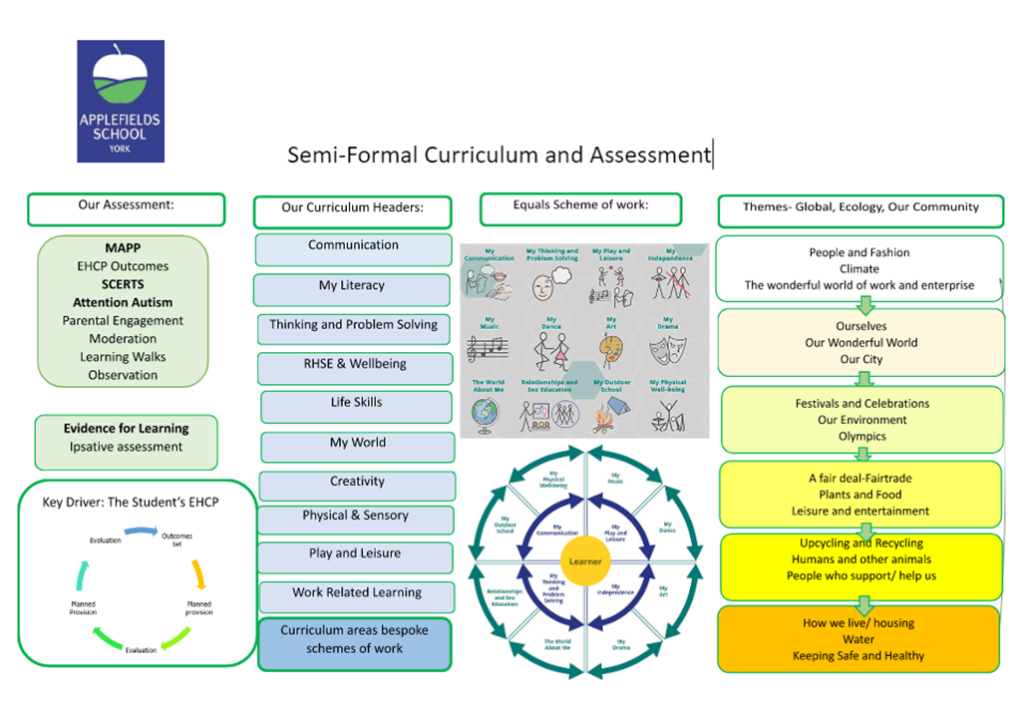

Based on the pedagogical reasons outlined, our curriculum is designed to be;

• Varied (non-linear)
• Personalised
• Holistic
• Concrete and contextualised
• Process-based
• Achievable

We have embedded it with the concepts taken from our MAPP assessment tool; independence, fluency, maintenance and generalisation (Sissons, 2010). We have adopted a semi-formal curriculum model, having researched and used aspects of the Equals model and Penny Lacey’s work. We have looked at other institutions (listed in references) to develop our own ideas on what is important to our learners here at Applefields.

KS3 | KS4 14+ Moving on Curriculum | MOZ
Communication  My Literacy  Thinking & Problem Solving  Life Skills  My World  Creativity  PE  Play & Leisure  Work Related Learning  Wellbeing | Communication  My Literacy  Thinking & Problem Solving  Life Skills  My World  Creativity  PE  Play & Leisure  Work Related Learning  Wellbeing | Life Skills  Transition  Pathways; Catering, Online Retail, DT  Play, Leisure, PE and Wellbeing  Communication and Thinking & Problem Solving is taught through the above

Where possible subjects are taught through a thematic approach, with a strong emphasis on life skills. Teachers adapt half-termly themes to meet the specific needs of pupils.

Programme of learning:

Our curriculum menu is designed to provide links to the most current, relevant information and pedagogical research.
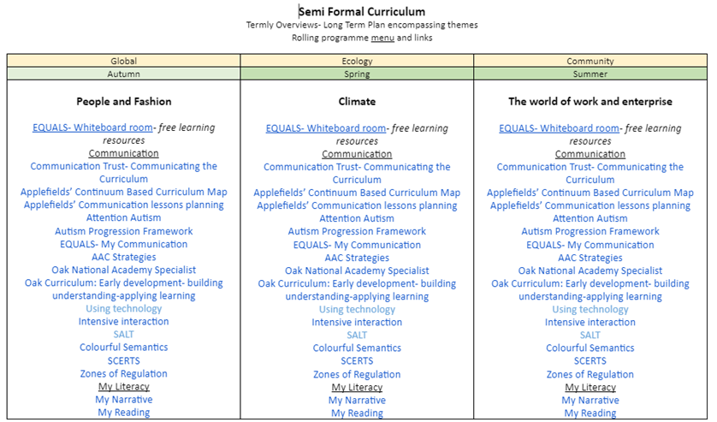
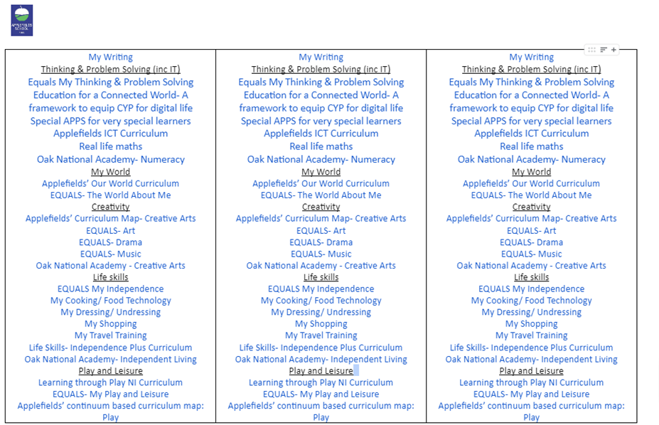
Our curriculum intent has small step objectives broken down in each curriculum area.
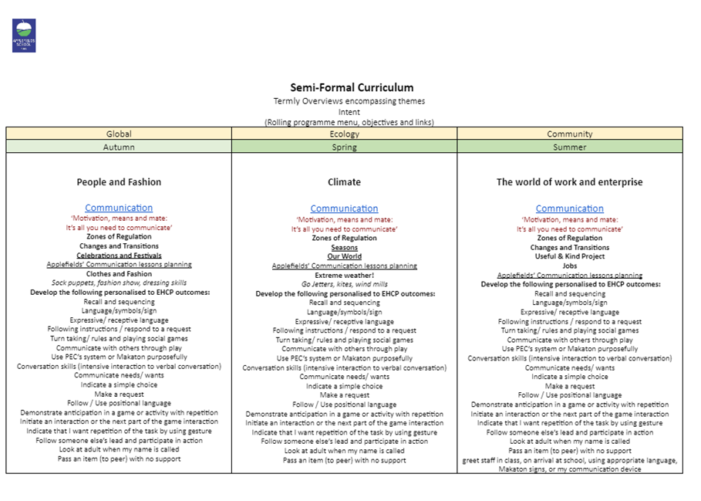

My Communication

Our Semi-formal learners may experience barriers to their learning that result from their Speech, Language and Communication Needs. These barriers may arise due to difficulties in one or more of the following areas – understanding and verbal reasoning, vocabulary development (both receptive and expressive), sentence structure and narration, literacy and social interaction. In addition, some students may experience difficulties in the areas of fluency and voice.

All students are taught in communication supportive classrooms. Staff provide opportunities for talk by;

- Providing opportunities for pupil participation
- Scaffolding questions to build confidence
- Giving students time to process information
- Making students aware of the range of resources available
- Supporting all students to reflect on “rules of dialogue”
Staff adapt their language by:
- Considering the length and complexity of language used
- Considering the range and level of questions students understand
- Encouraging discussion with peers; modelling / scaffolding if needed
- Teaching pupils how to recognise they need help and how to ask for help
- Checking for understanding, perhaps involving other adults in the class.

Students with high levels of need receive targeted support from our Language Therapist. The Speech and Language Therapist liaises with the teacher to set goals and provide a therapy plan and training where appropriate.

Supporting the development of core communication skills is a high priority. Effective communication is at the heart of every aspect of school life. Developing children’s speech, language and communication skills contributes to a wide range of positive outcomes in educational achievement, social competence, behaviour and mental health.

The wide range of learning, physical, sensory and health needs of the pupils means that a Total Communication environment is needed to meet the diverse communication challenges that the pupils face. This simply means communicating with people in the best ways that are accessible to them. A Total Communication environment addresses both receptive and expressive needs. It includes Augmentative and Alternative Communication (AAC) which is widely used at Applefields. This will include both low and high tech aids to communication such as symbol support, signing and electronic communication aids. Appropriate approaches and strategies should be used consistently by adults in all aspects of daily school life. However different methods or a mixture of methods may be used by the pupils in different situations. Where necessary, the Speech and Language Therapist will work with the class teacher to support the communication needs of the child/young person, set targets and suggest resources or a therapy programme.

The following areas are addressed:
- Comprehension /understanding of spoken language
  - Developing listening and attention skills
  - Receptive language development including -understanding of information carrying or key words; vocabulary building; concept development; verbal reasoning
  - The use of Augmentative or Alternative Communication (AAC) to support understanding of speech

- Expression
  - Expressive speech development (speech sounds)
  - Expressive language development including –vocabulary development; sentence building; narrative
  - The use of Augmentative or Alternative Communication (AAC) to support expression
- Interaction / Social Communication
  - Shared attention; turn taking; initiation of communication
  - The skills of the interactive process of communication; awareness of self and others and communication in a social context.

PE

Physical education is an important part of the curriculum and is incredibly important to all learners, including those with SLD. Programmes can look quite different for each pupil depending on the opportunities they are entitled to such as Physiotherapy sessions, Rebound Therapy, yoga, hydrotherapy and changes of position. PE for the majority of classes in school is taught by our PE specialist.

Life skills

Life skills should be a holistic approach to developing understanding about a range of things that are present in the pupil’s life. It may develop their independence, confidence, identity, self-belief and preferences as well their emotional wellbeing.
These attributes will of course also be developed through every area of the curriculum. It is really important for learning to be focused on the pupil and experiences that are personal and relevant to them.

Our life skills curriculum focuses on five core areas of learning. They are:

- Cookery
- Travel
- Community
- Home
- Self

My World

In addition to subject specific English, Maths and Functional English and maths, pupils follow a thematic based curriculum. By teaching in this way, it allows learning to be more natural, less fragmented and provides an ‘umbrella’ that links the development of knowledge and skills across a broad range of subject areas. This style of learning also enables pupils to revisit the same or similar ideas and apply them in different ways, resulting in a richer understanding of the topic. When planning for these topics, staff take into account personalisation for their class. Applefields school values; Wellbeing and Regulation, Communication and Independence, Personalisation and Preparation are at the heart of everything we do.

My Thinking & Problem Solving

Cognitive skills affect a pupil’s ability to think and reason, maintain attention and remember. A pupil with SLD may have difficulties developing these skills as they require use of part of the brain that may not function efficiently, leaving gaps in their visual and auditory processing capabilities. Pupils should be encouraged to process information, make sense of it and be able to apply it to a scenario. To develop cognitively, pupils must have first-hand experiences, which will need to be modelled and then repeated in order for them to understand and remember the process.
As always, it is particularly important to avoid doing anything for the pupil that it is possible for them to do themselves, as this will hinder the learning experience. Learning should be supported by visual and auditory clues where appropriate. My Thinking will help to develop memory, recognition and problem solving, evaluating those solutions as well as questioning.

My Literacy

My literacy is taught through a range of strategies including specific teaching e.g phonics (if appropriate), through communication e.g. weekend news, early literacy skills; sequencing, mapping, retelling, sharing books/ stories. It is split into three areas- My reading, My narrative and My writing and again taught through ‘real life’ experiences and play based learning. For more information, please refer to the ‘How we teach reading at Applefields School’ document.

Work Related Learning

Pupils should learn life skills that enable them to be active in routines and to complete everyday tasks more independently. Activities should be personalised to the pupil depending on things that are most important to them and their potential future independence. Some activities may reappear in this area from a core area and the purpose is to give the skills further context. Suggested activities include;
- Learning routines, Practicing transitions, Cause and effect
- Learning about familiar and unfamiliar people, Social boundaries
- Role play
- Games on the computer, Operating cooking equipment, Answering the telephone
- Practicing functional skills in different environments, Weather forecast
- Road Safety, Night and day, Days of the week
- Objects of reference, Sequencing
- Time and place, Mapping, Gardening
- Community experiences
- Packing their own bag to go home, Tidying away
- Conflict resolutions, Greeting people
- Using the cookery room, Using the photocopier, Listening to the news

Play and Leisure

Play is vitally important to the development of both the child and the adult that the child will become. All animals play; it is one of the crucial ways of learning within a safe and secure environment, but it must be given TIME. For those with learning difficulties, whose learning takes so much longer to develop, Play, with a capital P and as a key area of learning needs to be expanded at the rate and speed which each individual learner can make sense of. Play MUST take a central part in any Curriculum discussions, MUST be given time to develop and will probably continue to be central for the whole of the learners’ school career.
For those who are at the earliest stages of intellectual development, play, and playing games….
‘are not time out from real work; they are the most intensive developmental work you can do’ (Nind and Hewett, 2001; p66).
Functions of Play. There are very many functions of Play, among them being to help the learner to:
- experience interaction with others
- learn about social interaction
- practice and develop social communication
- encourage in the making of friendships
- learn new skills in a safe environment
- explore own body and senses
- develop kinaesthetic senses
- explore the surrounding world
- develop a safe understanding of emotions of both self and others
- develop fine and gross motor skills
- develop flexibility of thought
- develop Theory of Mind
- develop Central Coherence
Equals Semi-Formal Curriculum

Personal Development and Preparing for adulthood

Wellbeing and Preparing for Adulthood is the golden thread running through our Semi-Formal Curriculum.
These core skill areas are also developed through cross-curricular links, enrichment activities and extra-curricular opportunities such as bikeability and travel training.

What are Pathways?
Our Key Stage 4 tasters and Moving on Zone (MOZ) curriculum provides pupils with opportunities to experience work pathways, develop personal qualities and gain work-related skills to enable students to make an informed choice about their future. The current pathways we teach are;

- Cater 4 it
- Make it
- Sell it

Discovery Days

At Applefields we celebrate key events and religious festivals. This is one of the occasions in which the semi-formal students come together with the other curriculums to celebrate and learn as a whole school.

Visits

Visits include both enriching experiences and preparing for adulthood opportunities. We value repeated visits so that our pupils with SLD have the best possible chance at accessing their community in the future. This includes accessing public places such as going to the café or going to the shop. Pupils learn the sequence of the visit, how to pay for items and develop important communication skills.

My Creativity

Pupils with SLD benefit greatly from expressing themselves through the Arts. Encouraging imaginative thinking and expression can build confidence and influence communication skills. Subjects such as art, music, drama and dance are also key to developing conceptual understanding, giving meaning to more abstract concepts such as people’s emotions and feelings. Play is also key to developing imaginative skills, as well as social interactions and problem solving. Pupils with SLD are likely to have communication barriers that influence their experience but it is essential to support play in order to create learning opportunities, as play can develop skills in any or all of the core subject strands. It is important that we recognise the process that pupils go through during My Creativity and try to avoid a sole focus on the end product.

External visitors

We regularly have fantastic opportunities to work with external artists, theatre groups and companies. Our pupils mostly thoroughly enjoy getting involved and it’s amazing to see their confidence grow throughout the experience!

Wellbeing

Wellbeing and regulation are key to how our students learn, thrive and progress. We use the zones of regulation in classes and each class has individual reward systems in which they celebrate small steps. Our wellbeing team are on hand should students need a referral and specific work. We have Emotional Literacy Support Assistants (ELSAs) in school who will also work with students for short term projects.

British Values:

In 2014, the DfE reinforced the need “to create and enforce a clear and rigorous expectation on all schools to promote fundamental British values”. The Government set out its definition of British values in the 2011 Prevent Strategy. Listed below are the values with examples of how Applefields uphold them;
- Democracy; School council, fair trade committee, class rights and rules, voting, debates
- The rule of law; PCSO/ Police/ fire service visits, online safety, IPIP agreements, code of conduct
- Individual liberty; choices, independence- tuck shop/ café/ work experience/ pathways/ golden time, travel training, sports club, ASDAN- towards independence
- Mutual respect; circle time, check ins, wellbeing work, breakfast club, chill out rooms, achievement assemblies, coffee mornings
- Tolerance of those of different faiths and beliefs; RE lessons, YOYO Assemblies, festivals, events, themes

These five areas are taught across the curriculum and threaded through the work of the school. The sense of community is very strong across our school sites – staff, pupils, Governors and families are all part of our community.

RSHE

Teaching Relationships and Sex Education (RSE) to children, young people and adults with severe learning difficulties (SLD) will be very different to teaching RSE to neuro-typical conventionally developing learners.
Teaching is bespoke to each student’s identified needs and delivered sensitively and at their level of understanding and accessibility. We use the DfE guidance around SEND and also useful material such as the PSHE association, Jigsaw, EQUALS and the Autism Progression Framework.

The Planning Framework is organised into six sections:

1. Self-Awareness (Me, who I am, my likes, dislikes, strengths and interests)
2. Self-care, Support and Safety (Looking after myself and keeping safe; aspects of Relationships and Sex Education.)
3. Managing Feelings (Understanding feelings, and that how I feel and how others feel affects choices and behaviour; aspects of Relationships
and Sex Education)
4. Changing and Growing (How I and others are changing; new opportunities and responsibilities; aspects of Relationships and Sex Education)
5. Healthy Lifestyles (Being and keeping healthy, physically and mentally)
6. The World I Live In (Living confidently in the wider world)

Moving on Zone

When students are readying transition they may take a place in one of the MOZ classes in which they would take part in a pathway (listed above) alongside lifeskills, RHSE and leisure opportunities. All students are supported from year 9 with careers advisors and are supported through a transition day to visit suitable providers and work towards moving on to the next stage.

Possible destinations (not an exhaustive list):

Semi- Formal
Supported Employment  Vocational Learning  PLPs/Hubs  York College  Choose 2 | Blueberry Academy  Askham Bryan  Ampleforth Plus  Volunteering  Tang Hall Smart

3. Guidelines, Provision and interventions on the Semi-Formal Curriculum

For learners with complex needs life can become a fragmented series of events with little order. Without structure, learners may struggle to develop anticipation and memory. Therefore, it is essential to provide a simple, structured environment with ordered activities and routines. Teachers should use their best judgement to design a timetable to best suit the needs of their individual learners. Daily and weekly consistency is important and sessions such as Communication groups, PE and therapies also need to be considered.

Level of stimulation

Some pupils need wild and exciting stimulation to react but others need a gentle, slow approach. For example, some pupils may find a loud environment overwhelming. Pupils are observed carefully to see which level of stimulation is best for them.

Repetition

Most pupils with SLD need a huge amount of repetition to develop or even maintain a skill. A small number of activities should be repeated over and over again, rather than giving continually new experiences. This will give the opportunity to build anticipation whilst consolidating learning.

Intensive Interaction

‘Waiting Time, Pausing, Anticipation’
Learners with complex needs are sometimes slow to respond to stimuli. Waiting time is needed to process the information. Giving pupils adequate time and space to respond and process information enables them to share control and have equal interactions. By building pauses into familiar routines and activities we create opportunities for learners to ‘fill the gap’, for example, to make a response that indicates their wish for a desirable activity to continue. The idea is to give them an opening to make a communicative response.

Turn Taking

Turn taking is a challenging skill for students with complex needs. Pupils need to have opportunities to practise turn taking with other people and in different social situations. They will be more likely to generalise a skill and become more independent with it. Turn taking is about the start and finish of your part in activity or conversation, so that someone else can engage with you. The same principle applies to pupils with complex needs when they are turn taking with objects. The following can help pupils to develop the skill;

• make each turn very short and as the learner builds up confidence they will make a response, start to increase the length of time that each turn takes
• use short, concise and repetitive language
• give verbal reminders, along with a gentle physical reminder, if necessary
• give lots of opportunities to practise turn taking
• use one-to-one games with adults, small group turn taking activities with peers and adults and cause and effect switch computer activities/games
• Demonstrate to pupils the differences between turn taking and waiting

Staffing and grouping

Pupils with SLD need a high level of adult support; they also need time alone for relaxation and reflection. Pupils need to spend time with their peers and staff need to plan to support them in this. Staffing ratios allow for a high level of direct teaching but also for some structured turn taking opportunities to notice and interact with a peer and changes in levels of concentration and engagement. There are times when a higher ratio is needed (1:1), for example during physical activities.

Great teaching on the Semi-Formal Curriculum

Management and Organisation
• The teacher manages staff time so all pupils have their needs met
• Staff know what they are doing at all times in the day
• Teachers and staff must be flexible and be able to adapt to the pupils’ engagement and behaviour
• Staff work as a team with common aims and practices. They support each other to meet the pupils’ needs
• Teachers are responsible for planning documents but all staff contribute ideas to them
• Teachers and staff meet regularly to discuss individual pupils and the plans for teaching and learning
• Teachers meet with therapists to agree on pupils learning goals
• Staff are focused on the pupils during the school day
• Pupils are engaged with activities when supported by staff
• If they are able, pupils engage with activities unsupported
• Waiting times for pupils to be engaged are minimal and individually appropriate
• Pupils are grouped appropriately to support their learning
• Staff know how to work with pupils whose behaviour can be challenging
• They have a plan B when plan A doesn’t work

Teaching and Learning
• Staff know pupils’ outcomes and can provide suitable activities to practice them
• Staff understand what is included in the areas of learning for pupils with SLD
• Teachers know what they are teaching and why
• Staff know how to challenge pupils sufficiently
• Staff provide suitable resources for individual pupils and adapt accordingly
• Staff communicate at a level pupils can understand and know when to use supportive AAC
• Pupils are encouraged to interact with each other
• Pupils are enabled to learn in an atmosphere of fun and enjoyment
• Teachers continuously evaluate progress made towards pupil outcomes

Support for Learning:

Sensory Cues

Many SLD learners would benefit from ‘sensory cues’. Pupils need to be given a consistent routine to help them begin to learn to distinguish activities and people so eventually they can begin to anticipate what is going to happen to them. Some cues will be particular to individual pupils, for example, singing a particular song. Some sensory cues are built into the activity, for example, the smell of lunch or a coat for home time. Use natural cues wherever possible, maybe exaggerating them, for example, jingling the bus keys or knocking the spoon against the bowl; anything to help children to associate that cue with what is going to happen next.

‘5 Minute Warnings’

As well as needing a sensory cue prior to an activity, some pupils with SLD may also benefit from a five minute warning before the end of an activity so that they have time to process what is going to happen. This may be as simple as holding up a sign, using a sand timer or shaking a tambourine whilst saying ‘5 minutes left’.

Visual Timetables

To support daily structure further, visual timetables are used in class rooms or a personalised timetable for an individual pupil. These can include activities for a whole day or be as simple as a ‘now’, ‘next’ and ‘then’ board. Certain pupils may need different information to meet their needs. For example they may need warning if they are going to be going outside or working with a certain member of staff. Some pupils may need to know what they are doing for the whole day and others it may only be suitable to know the structure of the morning.

These are also suitable to be used during sequencing tasks, for example having photographs of each stage of making a meal. Pupils could follow photographs as a recipe or it may be their task to order the photographs themselves, depending on the ability of the learner.

Colourful Semantics

Colourful Semantics is an approach used with children with a wide variety of language and communication difficulties. It is based on independent research carried out in the UK by Speech and Language Therapist, Alison Bryan (and others) between 1997 & 2011. The approach helps pupils to understand relationships between the different sections of simple sentences and to express these. Developing understanding of the meaning of words is something that our pupils with SLD generally struggle with, therefore this approach has been a successful teaching strategy in many classes.

Some groups may use this approach through symbols to build up sentence structure and develop speech whereas other groups may be developing thinking, encouraging creativity within their writing or sequencing.

Symbols

We use Wigit online to create symbols and try to ensure consistency in symbols used where possible. It is suitable for most of our pupils with SLD to use the simplest symbol available.

Signing

We are a Makaton friendly school and use Makaton as our main method of signing. Makaton is a language programme that uses signs to help people to communicate. It is designed to support spoken language therefore signs are used as well as speech, in spoken word order. Pupils will access signing at a level that meets their needs, even if it is to communicate ‘toilet’ or ‘drink’ whereas other pupils use a wider range of signs throughout their daily routines.

RM Easimaths and Wordshark

If appropriate, some pupils use RM easimaths and Wordshark programmes as an intervention to consolidate core English and Maths skills.

4. Recording and reporting

EHCP outcomes and Tracking:

Outcomes are written by the class teacher, class team, parents, students (where appropriate) and wider professionals and are agreed at EHCP meetings and parental consultations. Parents are invited for consultation each term to discuss progress and revise outcomes.

In addition to this, outcomes from each pupils’ Education, Health and Care Plan are monitored and tracked during termly pupil progress meetings with a member of Senior Leadership. Information is used to create case studies, provide interventions and create impact reports. This robust way of monitoring is summarised and presented for the scrutiny of school Governors.

Steps to pupils achieving outcomes and achievement of outcomes are recorded in our assessment tools, MAPP and EfL.

A blank example of Applefields EHCP monitoring table below:

Pupil name
This section completed by:
At the last review, this is what we planned for the child/young person to do or learn.
How did the child/young person get on and did it make a difference? (Achieved / Partially Achieved or Amended)
Short term Outcome | Date outcome set | Progress made October | Progress made February | Progress made May
N1 Communication and Interaction
N2 Cognition and Learning
N3 Social, Emotional and Mental Health
N4 Physical and Sensory Needs (Vision / Hearing)
N5 Sensory Needs
N6 Preparation for adult life

MAPP and EfL

We use the MAPP assessment tool; independence, fluency, maintenance and generalisation (Sissons, 2010) to track progress in areas where students have identified needs. Areas are;

- Communication and interaction
- Cognition and Learning
- SEMH and Wellbeing
- PFA
- Sensory (if identified needs in this area)
- Physical and medical (if identified needs in this area)

The system tracks good, expected, and stagnated progress and is monitored through termly pupil progress meetings. The Continuum is based on a 10 stage scale and this means we can track and record small steps of progress our pupils make within their goals.
Our Evidence for Learning (EfL) tracking system measures and monitors progress in each area to enable us to provide support and interventions where necessary. We do not believe our student’s progress is comparable with each other due to their individual special educational needs and disabilities.

from dependent INDEPENDENCE to independent
Learners complete tasks independently
The task is carefully scaffolded and the learner is fully prompted throughout. | Some elements of the task are completed without support (or the overall level of support is lighter, for example physical help is replaced by gestural help). | The learner performs the task with minimal support. Encouragement may be given, and prompting may be needed to initiate the relevant skill(s). | The learner initiates the appropriate action and completes the task independently without prompts or other external cues.
1 2 | 3 4 5 | 6 7 8 | 9 10

from approximate FLUENCY to accurate
Learners reach a level of mastery combining speed and accuracy
The skill is approximate and the learner’s behaviour needs considerable shaping in order to accomplish the task. Performance is slow and halting. | The learner’s performance is increasingly purposeful and coordinated, but it is not yet sufficiently accurate to effectively accomplish the task. | Performance is sufficiently accurate to meet the requirements of the task which is completed with little faltering or hesitation. | The skill is smooth, swift and accurate. No further refinement is needed.
1 2 | 3 4 5 | 6 7 8 | 9 10

from inconsistent MAINTENANCE to consistent
Learners maintain competency over time through repetition. They remember how to do a task after a break
The skill has been observed on a single occasion or, at most, on sporadic and isolated occasions. | The skill is demonstrated on repeated occasions. Performance is not yet sufficiently consistent to be reliably anticipated. | Performance of the skill is consistent and can be reliably anticipated.  The skill needs refreshing after a break. | The skill is consolidated and maintained over time. It is remembered after a break and any loss of quality is quickly recovered with practice.
1 2 | 3 4 5 | 6 7 8 | 9 10

from single context GENERALISATION to many contexts
Learners achieve mastery in different settings or contexts, with different stimuli or with different staff
The skill is demonstrated in a single setting or context, with limited stimuli or materials and with the same staff. | The skill is repeated but with some variation in setting, context, materials or staff. | The skill is demonstrated in different settings or contexts, with different stimuli or materials and with different staff. | The learner applies the skill to meet the demands of a new situation.
1 2 | 3 4 5 | 6 7 8 | 9 10

Planning Expectations

When planning, teachers should take the following into consideration;
• Prior learning – needs to be assessed accurately and in detail
• Early child development
• Pupil Outcomes and future LTO/ destinations
• Materials and resources – are they interesting and motivating?
• Balance – between keeping things fresh and interesting and allowing enough repetition for learning

When planning it should include the following information:
- Learning intentions (INTENT)
- Success criteria (Key steps a pupil needs in order to fulfill the learning intention) (IMPACT)
- Differentiated activities and resources (IMPLEMENTATION)
Great short term planning will include;
  - Shared LI and success criteria written in child friendly language. (These could be shared through a Google Slides presentation, visual or worksheets)
  - Shared LI focus on the learning journey, not just the completion of the task or activity.
  - Information on deployment of staff eg 1-1, small groups

Marking & Feedback

We praise, celebrate, reward and use positive reinforcement and the use of modelling for our semi-formal learners. If appropriate for the learner, then verbal and written feedback, in-line with the school Feedback and Annotation Policy, may be provided.
These written comments should:
- Be directed to the student, be positive and celebrate effort and achievement
- Relate to learning objectives

Teachers should indicate next steps for improvements or correcting errors on a pupil's work. Opportunities are given for these points to be shared, reflected upon and action taken. Where a pupil has received verbal feedback, the teacher is required to write VF on the pupils work.
Teachers and teaching assistants are required to provide verbal and written feedback to pupils. Prompt support sheets are available in all classrooms to support staff with this.

Code |  | Levels of support/ annotation codes explained
I | Independent: The task was completed independently
SH | Spoken help: Including signing and verbal prompts to remain on task
GH | Gestural help: Help from someone who has used gestural cues
PH | Physical help: help by someone holding / helping a student move
C | Corrected: Work corrected/ requires correction
 | Next steps: Target/ challenge or next steps information recorded for student
S | Scribe: Work/ notes recorded by someone else
VF | Verbal Feedback: Verbal feedback has been provided following the task

Assessment

The Rochford Review states ‘it is neither possible nor desirable to set national expectations for what these pupils should have learned at a particular age or by the end of a key stage…as assessment for pupils with severe learning difficulties should be suitable for each pupil’s individual needs, the review does not feel that it would be appropriate to prescribe any particular method for assessing them.’ In response to this advice, we use a toolbox of assessment and a menu of links and approaches when assessing our pupils that will allow all aspects of learning to be captured and considered.

Assessment on the Semi-formal Curriculum across the Key Stages

We do not compare the progress of our pupils with the progress of pupils in other schools. We believe this is meaningless as one young person with SEND is very different to another young person with SEND, even if they have the same diagnosis, learning difficulty or medical condition. We have made this decision based on research by Peter Imray, Penny Lacey and following the publication of the Rochford Review recommendations. However, we do value and learn from working with other SEND schools within the EfL community. Because our assessment systems are different for each curriculum, we have decided not to compare the progress of pupils between curriculums.

Recording and Reporting

Teachers will follow the phases of assessment outlined below;
- Baselining – teachers will agree long and short term outcome priorities for the pupils in their class with families for the broad areas of need (Cognition, Communication, SEMH, PFA and if appropriate Sensory and Physical and Medical). They will then baseline against the MAPP scoring scale which will be recorded on the pupils own MAPP on EfL.
- Formative assessment – teachers will collect evidence and make frequent judgements through class assessments against the outcomes and mark these on EfL.
- Summative assessment – data will be entered onto the MAPP termly record on EfL to mark achievement towards their goal with regards to prompting, fluency, maintenance or generalisation and the data will be summarised for teachers to then meet with the ELT curriculum lead to review progress so far and put support in where necessary. This data will be used to complete their termly reports.

5. Key information

Definition of SLD

Pupils with severe learning difficulties (SLD) have significant intellectual or cognitive impairments. This has a major effect on their ability to participate in the school curriculum without support. They may also have difficulties in mobility and co-ordination, communication and perception and the acquisition of self-help skills. Pupils with severe learning difficulties will need support in all areas of the curriculum. They may also require teaching of self-help, independence and social skills. Some pupils may use sign and symbols BUT most will be able to hold simple conversations. Their attainments may be within the upper P scale range (P4-P8) for much of their school careers.’
(DfE definition of SLD)

SLD (Semi-Formal Learners) - Needs & Barriers to Learning

Pupils with SLD experience significant barriers to their learning. They have a severe learning difficulty as well as additional sensory or physical difficulties. This means they usually:
• Consistently learn between P4 – NCL2
• Experience difficulty communicating
• Require additional support with most aspects of daily life
• Have some complex health needs and/or challenging behaviours
• Have difficulty with abstract concepts
• Have difficulty with concentration and attention
• Have difficulty with short and long term memory
• Have difficulty with sequential memory
• Have limited working memory
• Have poor general knowledge
• Experience difficulties with problem solving
• Have difficulties with generalised understanding (Imray and Colley)

These barriers can lead to:
• Lack of information about their world
• A distorted perception of the world
• Learned helplessness
• Lack of ability to anticipate events / activities
• Limitations in their ability to explore
• Suffering the effects of ill health
• Difficulties in establishing and maintaining interpersonal relationships

Therefore, pupils with SLD need:
• A significant adaptation to the curriculum
• A curriculum that is delivered at the right pace, focusing on overcoming their barriers
• A high level of specific multi-agency support
• A modification of the physical environment
• A high level of specialist resources
• A high level of individual care and support

To address and minimise the effects of these barriers, the Semi-formal curriculum at Applefields focuses on developing pupils’ skills and abilities. The Semi-formal curriculum is driven by the identification of individual personalised learning goals within their EHCPS and also providing opportunities for students to develop in the broad areas of need (Communication, Cognition and Learning, SEMH, Physical and Medical and Preparation for adultlife. This is all closely aligned with our school values of Personalisation and Preparation, Wellbeing and Regulation and Communication and Interaction.

References and Acknowledgements:

DfE Special educational needs and disability code of practice: 0 to 25 years, January 2015
Rochford, D, October 2016, The Rochford Review: Final Report

Ashfield Academy, Leicester

Swiss Cottage School, Camden

Dales School
DfE Special educational needs and disability code of practice: 0 to 25 years, January
EQUALS Curriculum
Swiss Cottage
Sissons M (2010) MAPP: Mapping and Assessing Personal Progress. North Allerton. The Dales School.

Applefields School
Bad Bargain Lane
York
YO310LW
Tel: 01904 553900
Email: info@applefieldsschool.co.uk

Last Update September 2022

