How Do We Teach Reading at Applefields School?

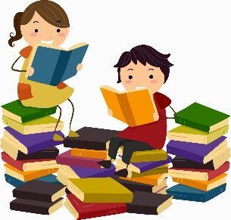

Schemes of Work:
At Applefields, we use the Equals scheme of work, research and methodology. We use the simple view of reading to understand where our learners are working:-
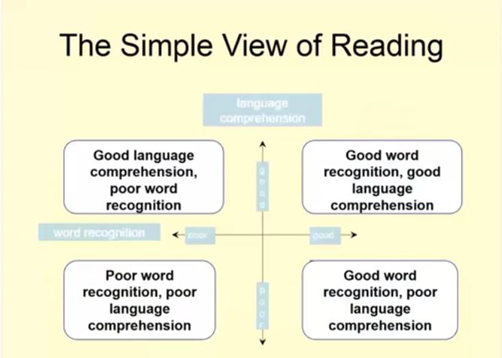
We also take account of potential ‘spikey pupil profiles’, particularly with regard to pupils on the autism spectrum: ‘The Equals formal English scheme of work suggests that pupils should be offered a project driven, holistic, process based teaching model’.
Equals state:
- “Pupil led learning will inevitably lead to engagement and validates an individual’s life and interest
- If teachers concentrate on the process of engagement, pupils can be guided towards learning
- The goal is …… for each learner to find meaning in text and make the best possible use of text, whether that is at the level of single symbols or connected prose.
- That whilst the phonics model is essential if the pupil is to become a fluent reader, not everyone is able to become a fluent reader and a different model to phonics needs to be applied to this population.”

Reading Strategies/Methodologies Used in School:
Phonics
Learning to read, through the teaching of phonics is recognised as just one of the many ways our students at Applefields can learn. Some students will benefit from our phonics scheme ‘Twinkl Phonics SSP’ (systematic synthetic phonics). This details exactly how phonics should be taught. In conjunction, we use some elements of the resources & ideas in the scheme ‘Letters & Sounds’. For some of our pupils, the many other methods of teaching reading are listed below.
Decoding/Encoding
Developing decoding and encoding skills is essential for a solid understanding of reading. Decoding is the process of reading words in text. When a student reads the words 'the car is red’, for example, it is necessary to understand what the letters are, the sounds made by each letter and how they blend together to create words.
Encoding is the process of using letter/sound knowledge to write. If a student were to write that same sentence, instead of making sense of the letters in text, it is necessary to recall sounds and the symbols assigned to them to write the letters together to form words.
Segmenting/Blending
Segmenting is the process of splitting words into its graphemes and phonemes. Blending is the process of putting these sounds back together.
Whole Word Reading
For some students, hearing and identifying sounds (segmenting), plus putting sounds together (blending) is really hard. There are several things which make can make learning to read using phonics a difficult task, particularly if the student may have a dyslexic profile:-
- The student may not be able to hear the difference between phonemes which sound the same.
- The student may not be able to say the sound due to speech and language needs.
- The student may understand the principles of phonics, but cannot apply them because of their inability to perceive the sequence, direction or sounds of letters/words due to disorientation.
- The student understands the principles of phonics, but is confused by words that are not spelled how they sound. If the student is over-reliant on phonetic strategies, this will hinder them further.
For pupils with this kind of profile, a whole word reading strategy may well be the best way forward. This can work for the student who sees the word as a pattern and/or shape.
Precision Teaching
Precision teaching is a structured teaching method, which is designed to improve the accuracy and fluency of reading, spelling and maths. The main goal of precision teaching to aid reading, is to help ensure that students become fluent and accurate in their recognition of words at sight and at speed, removing the need for segmenting and blending. It is one of the most effective teaching strategies for ensuring high levels of fluency and accuracy.
Precision Teaching involves short, one minute tasks to build skills by practising them regularly. It lets you monitor and track the progress the student makes very carefully and make changes to ensure the student is learning as fast as they can. It is not in fact ‘teaching’ in the full sense but is a tool to help highly effective teaching and support where a student is finding something difficult or where the skill they need to learn needs to be fluent and automatic. Carefully designed tasks allow students to practise key skills until they are fluent. It also provides the mechanisms for assessing and monitoring progress.
PECS
This stands for picture exchange communication system. PECS consists of six phases and begins by teaching an individual to give a single picture of a desired item or action to a “communicative partner” who immediately honours the exchange as a request. The system goes on to teach discrimination of pictures and how to put them together in sentences. In the more advanced phases, individuals are taught to use modifiers, answer questions and comment. The primary goal of PECS is to teach functional communication, however it has a direct link with reading by developing a student’s understanding of how symbols carry meaning.
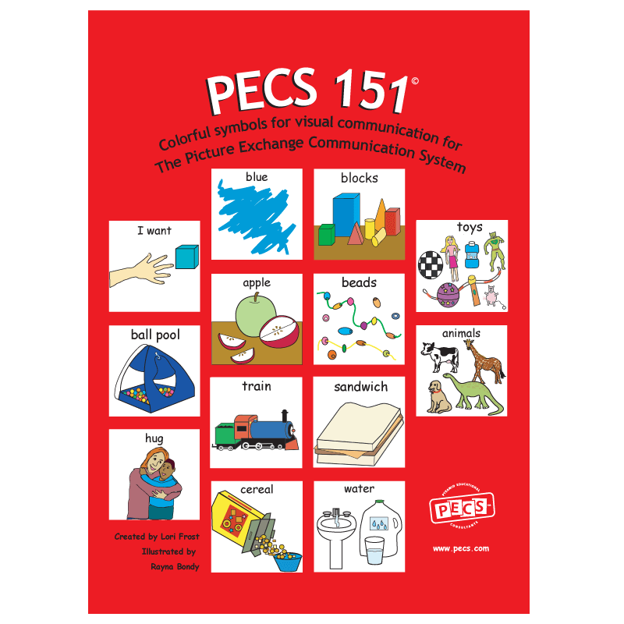
Cloze Procedure
A cloze exercise is a type of reading comprehension activity. It has a passage of text with missing words -students need to fill in the blank spaces using words from a list or word bank. The words are usually removed at regular intervals, such as every five words. The reader has to use background experience, knowledge of syntax, vocabulary, interest, and, generally, higher order thinking skills to fill in the blank and complete the idea/sentence. These can be created using Clicker (see later in the document).
Colourful Semantics
Colourful semantics is a teaching approach that aims to teach children to develop sentence structure. Although more often used in teaching writing, its use will also develop a student’s comprehension when reading. It supports spoken and written language learning across the curriculum and aims to help students develop skills when it comes to sentence development, understanding questions, developing narrative, understanding written text and developing vocabulary. Colourful semantics are often used to support children with speech and language difficulties, and/or those who have difficulties with word order, vocabulary difficulties or expressive and receptive language difficulties. As a teaching approach, it can be particularly useful to support reading, for students who struggle in any of the following areas:
- Putting sentences together in a meaningful order.
- Confusing the order of words in sentences.
- Missing out verbs and other key details in sentences.
- Always using the same sentence structures.
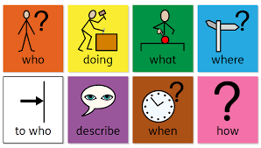
Shared Reading
Shared reading is an interactive reading experience where students join in or share the reading of a 'big book' or otherwise enlarged text (such as projected on an interactive whiteboard) while guided and supported by a teacher. The text must be large enough for all the students to see clearly, so that they can share in the reading of it.
During shared reading, the teacher can demonstrate various reading strategies and model fluency and expression through reading aloud. As the teacher reads, students should follow along and be actively engaged. When confident, they should join in with the reading, too.
The main purpose of shared reading is to provide students with an enjoyable experience. During these sessions, they are introduced to a variety of authors and types of texts to entice them to become a reader. These shared reading sessions are also designed to support young readers who might not be as confident when reading independently.
Guided Reading
Guided reading is a small-group reading strategy, created to provide differentiated teaching to students. Guided reading supports children with a similar profile of needs, in developing their reading skills. Being in a smaller group allows them to be taught in a way that is more focused on their specific needs, which can accelerate their progress.
The purpose of guided reading is for students to problem-solve and practice strategies using texts appropriate to their level of ability. The aim is for all students in the group to use the focus strategy of the session (reading words with suffix ‘ing’) to an entire text, not just a page. It gives pupils the chance to apply any strategies they already know to a new text, expanding their understanding at the same time.
During guided reading, pupils individually read a text that the teacher has selected at their reading level. It helps pupils develop reading strategies, which support decoding and constructing meaning. The teacher guides, or 'scaffolds', the students as they read, talk and think their way through a text. Students are guided towards learning things they cannot learn on their own.
Reciprocal Reading
Reciprocal Reading is a structured method of guided reading where students are taught to take on group roles to explore and understand texts. Reciprocal reading emphasises teamwork and supports independent comprehension skills. Reciprocal reading is used with reading comprehension exercises. Each student has a different role in the group and performs set tasks:
- The Leader decides who will do what and is in charge. The Leader introduces the text and ensures everyone is joining in and following.
- The Predictor asks all the readers to make predictions about the text based on information they already know. What do you think will happen? What will happen next? What will this character do now?
- The Clarifier helps the group to identify confusing words, sentences and ideas. They help the group to understand the text. It can be useful to ask each reader to highlight confusing words, sentences and/or passages for discussion as soon as the reading is over.
- The Summariser helps the group to identify the most important ideas in the text and what the text is mainly about.
- The Questioner asks questions about the text.
- The Illustrator draws or illustrates what they have read about in a picture, diagram or cartoon.
- The Passage Master looks for what they think is the most interesting passage in the story and justifies their selection to the group.
- The Feelings Finder finds word or parts of the story that show or describe feelings or emotions.
- The Word Finder picks out new or interesting words used by the author and can give their definition.
- The Link Maker links between this story and other stories or real-life events.
The students work together, play their different roles, resulting in a more thorough understanding of the reading text, while also gaining valuable teamwork skills.
Sharing books with students
Never underestimate the importance of sharing books with students and reading to them. Whether whole class or 1:1, sharing a book can bring huge enjoyment to the student. It can be a special time where relationships can be built. It also promotes a love of and interest in reading, whether it be comics, picture books or longer novels. It can be linked to our whole school topic, class interests, or particular authors. It might be fiction or non-fiction but is a wonderful opportunity to develop students’ interest in books, comprehension and enjoyment of stories. It can also be a calming time for students, helping them to regulate and relax. A book can be read to a student that they would otherwise be unable to access, thus bringing higher-level interest to students with less or very little reading ability. It can also develop students’:
- Understanding of stories
- Appreciation of how text carries meaning
- How to track information across a page
- The difference between text and images
- Knowledge & use of higher level vocabulary
DART
This stands for directed activities related to text. DARTs are activities which get more formal students to interact with texts. Their aim is to improve students' reading comprehension and to make them critical readers. They can be done by individual students or in groups. The type of activities you can use can be divided into two groups:
- Reconstruction activities:
These are activities that require students to reconstruct a text or diagram by filling in missing words, phrases or sentences, or by sequencing text that has been jumbled. The teacher could use modified texts with words, phrases or sentences taken out, or the text could be cut into segments.
Types of activities:
- Text completion (Fill in missing words, phrases or sentences.)
- Sequencing (Arrange jumbled segments of text in a logical or time sequence.)
- Grouping (Group segments of text according to categories.)
- Table completion (Fill in the cells of a table that has row and column headings, or provide row and column headings where cells have already been filled in.)
- Diagram completion (Complete an unfinished diagram or label a finished diagram.)
- Prediction activities (Write the next step or stage of a text, or end the text.)

- Analysis activities:
These are activities that require students to find and categorise information by marking or labelling a text or diagram. Unmodified texts can be used here.
Types of activities:
- Text marking (Find and underline parts of the text that have a particular meaning or contain particular information.)
- Text segmenting and labelling (Break the text into meaningful chunks and label each chunk.)
- Table construction (Draw a table. Use the information in the text to decide on row and column headings and to fill in the cells.)
- Diagram construction (Construct a diagram that explains the meaning of the text. For example, draw a flow chart for a text that explains a process, or a branch diagram for a text that describes how something is classified.)
- Questioning (Answer the teacher's questions or develop questions about the text.)
- Summarising
Visual Cues/Pictorial Representation
Much of the reading we do in school is heavily supported by visual aids and prompts. Where possible, signs in school are a combination of words accompanied by symbols. We have a programme to create this, called ‘In Print 3’. This is a useful tool which can also create books, recipes, visual timetables etc. These clear images/symbols add a crucial level of comprehension:
Developing Comprehension
This is done in many ways throughout all the other aspects of reading covered here. Different levels of comprehension will be covered, depending on student ability. We are able to use ‘Small Steps of Learning’ to chart progress, within our evidence for learning assessment tool. Comprehension for some pupils will involve discussion, some will be encouraged to write a response to reading and some will show their comprehension through pointing or gesture.
Bloom’s Taxonomy
Bloom’s Taxonomy fits into six categories: remembering, understanding, applying, analysing, evaluating and creating. Each of these levels use gradually more complex kinds of comprehension. Asking questions based on these categories can be a useful way to assess reading ability in CYP.

PEE
This is used with more formal learners, to further develop their comprehension, and provide a means for proving their response to a question. It stands for the following:
P – make a point from the text
E – evidence the point with a quote from the text
E – explain why the quote answers the point
Students can PEE any kind of question in any subject
Functional/Real Life Reading
Many of our students will learn to read and develop their reading skills through text in the environment. Students who are visual learners, or who benefit from visuals, will learn to read whole words through seeing shop/cafe/restaurant signs, street signs and product logos. Often students can use their visual memories really well to remember these images, which ae familiar and easily identifiable.
Paired Reading
The tutor and student both read out aloud together. The tutor can be slightly ahead, or read alongside the child in unison. When the student feels confident enough to read independently they give a signal, such as a knock on the table. The tutor will then only join in again if and when the student misreads a word – the tutor states the correct word via direct instruction, the student repeats it and they then carry on reading again together. The process continues. This strategy can develop a pupil’s confidence, sight vocabulary, accuracy and fluency when reading.
Peer Reading Partners
Paired reading is a research-based fluency strategy used with readers who lack fluency. In this strategy, students read aloud to each other. When using partners, more fluent readers can be paired with less fluent readers, or children who read at the same level can be paired to reread a story they have already read.
Pupil has 2 books – one for decoding and one for comprehension
For some more formal learners in school, it is useful to give them two different sorts of reading books in parallel. One book is aimed at developing their decoding and encoding skills. This book can be closer to their reading age and more challenging. It is used to develop their skills in reading individual words. The other book would be used to develop the student’s comprehension and would be simpler, containing words they could easily decode. This helps, because a student who is decoding every word as they read, will very quickly lose understanding of the text.

Resources Used in School:
Reading Books
At Applefields School, we have decided to arrange our scheme books in coloured book bands. Some schools book band according to the phonics phases. We have decided to band ours more in line with reading ages and levels. This is because reading through phonics is not an approach we can use with all, or indeed many of our students, due to their complex needs and varied learning styles.
Our reading books are a combination of books from a variety of different reading schemes, including Ginn Zoom, Rapid Read and Rising Stars Dockside. They are arranged in 16 coloured book bands, which range from light pink (early level P1) to black (second level plus/P7-S1+). Some of the schemes are included for a specific purpose, such as ‘Rapid Read Books’, which have a high interest level, coupled with a lower reading ability level. They are graded in difficulty, but allow older pupils to read about subjects or themes they enjoy, with words and a comprehension level that is simpler. Some schemes provide a high frequency word approach, such as Crick Planet Wobble.
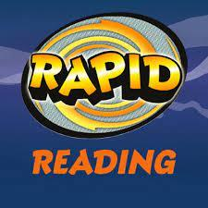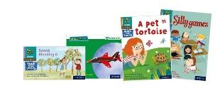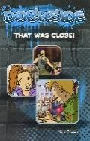
Other schemes we have are more phonic based, such as Read, Write Inc Phonics and Jelly and Bean.
Communication Aids
There are a number of communication aids available and we use several in school. One of which is Proloquo2Go. This is an easy to use communication app for people who cannot speak or need help being understood. It offers an alternative way to communicate. It consists of natural sounding text-to-speech voices, up-to-date symbols, automatic conjugations and vocabulary of over 7000 items. It uses an adaptable, multi-size grid format to present images and words on "buttons." Buttons represent different groups of items, actions, "little words," and more. Students can choose from single words or combine words to make detailed sentences that express their wants, needs, or emotions. You can add buttons using your own pictures or images that are meaningful and personalised to each user. It is a simple yet powerful AAC (augmentative and alternative communication) tool, designed to help students progress from recognizing graphic symbols to printed words. As the user grows in their literacy skills, they are immediately rewarded with new messages they can communicate.
Another one we use is called LAMP, which stands for Language Acquisition through Motor Planning. It is a therapeutic approach using motor learning principles and a voice output communication aid to give non-verbal individuals with autism and other developmental disabilities a method to develop independent and spontaneous communication.

Audio Reading
Students are encouraged to listen to stories and books too. These audio books are available within our subscription to Oxford Owl. They are also available free on sites such as:-
- youtube & spotify
- librivox.org
- storynory.com
- loyalbooks.com
- Libby (the York libraries app)
- K12 Read Aloud Classics app
- storylineonline.net
- getepic.com
Sensory Stories
Beyond being a wonderful way to share stories in a sensory manner sensory stories can be
used to support people and develop abilities in a vast array of ways. Many of our ideas are taken from the book 'Sensory Stories' by Joanna Grace.
Sensory stories can be used to support individuals with sensory processing disorder, autism, learning disabilities, ADHD, PMLD, communication difficulties and mental health needs to:
- Introduce them to new experiences.
- Build up tolerance to difficult experiences.
- Learn direct or compensatory strategies to cope with experiences.
- Engage in communication in a non-stressful way.
- Make connections with peers.
- Prepare for an event or new experience.
- Develop and discover strategies for coping with sensory related anxiety.
- Help them to concentrate for a prolonged period of time.
- Provide an environment for them to rehearse the underpinning skills needed for
- concentration.
- Give them access to narrative in a way that is not wholly reliant on language.
- Enable you to share a narrative through sensory media.
- Support postural care.
- Support the communication of likes, dislikes, preferences, understanding and knowledge
- Support mental well being.
- Support active engagement with the world.
- Provide a supported way of saying a word.
- Express themselves.
- Engage in the sensory world: engagement in the sensory world has been shown to be
preventative of depression, anxiety and stress.
Wordshark
Wordshark is a fun and effective computer programme, which helps students to read and spell. It is games-based which students find entertaining and motivating. It is especially helpful for students with specific needs such as dyslexia. Students can log in from home or school and it is a progressive programme. Staff can customise both learning and games to a particular student’s needs. The 10,000 words in Wordshark are grouped in easy-to-use, structured courses. School has purchased this resource and students have their own log in.
Online Reading – Oxford Owl
This is an online reading programme. It contains educational resources and free eBooks to support pupil's learning at primary school and at home. It contains teaching, learning and assessment resources. Books can be chosen for a range of student reading ages and interests. School has purchased this resource and students have their own log in.
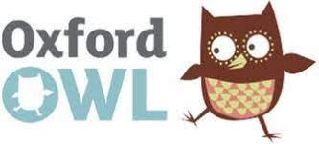
Clicker 8
Clicker is an online writing solution for the classroom. It allows students to structure and create writing in a variety of ways, including using sentence sets, mind maps, spelling aids, free writing tools and visual symbol creation. In terms of reading, it is a tool staff can use to prepare text for a purpose, with visual supports, such as a recipe, instructions or writing about an event. It develops students’ single word reading, comprehension of vocabulary and understanding of what a sentence is. By using it as a writing tool, students can practise their reading in a fun and motivational way. School has purchased this resource. It works on an Ipad, chrome book or laptop.
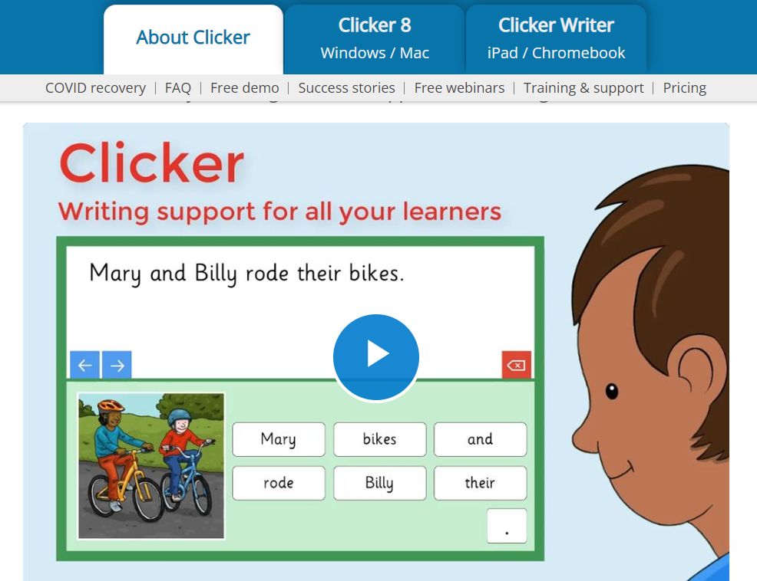
Flashcards
For some pupils, the use of flashcards with key words or phonics patterns/sounds can be useful. Picture prompts can be added to these to make the word or sound easier to recognise and faster to learn using ‘In Print 3’). Pupils can also be encouraged to draw their own jotting to accompany a sound or word on a flashcard.
First News
First News is an online newspaper, aimed at CYP. Students can log in at school and at home. It contains relevant and current articles about the news, delivered in an attractive and motivational format. It is differentiated, and also contains interactive comprehensions, puzzles & polls. School has purchased this resource and students have their own log in.
Sound/Word mats
These are useful for students to refer to in order to remember a particular sound or word when reading. The word/sound would usually be accompanied by a simple picture or symbol to aid word/sound recognition.
Assessment of Reading:
Evidence for learning (EFL) is our school system, by which staff and families can upload information of a student’s learning journey in reading. Our small step assessment tool within EFL (for formal learners in KS3/4 and the Moving On Zone) enables teams to record the progress made, identify strengths and areas to target through interventions. Education, health and care plan (EHCP) outcomes in cognition and learning are personalised for each student and the journey to completing these outcomes is cross-referenced with Mapping and Assessing Personal Progress (MAPP) (also within the EFL tool). MAPP shows the student’s independence, fluency, accuracy, maintenance and how they are generalising a skill.

Sally Firth – May 2022

